Just in Time
Presentville's laboratory created a tear in space-time, trapping the city in a destructive vortex somewhere outside of reality. The players must work together, traveling through time and place, to realign their recent history before it, and they, cease to exist.

Just in Time is a real-time cooperative abstract on time-travel for 1 to 4 players. Players take actions as quickly or slowly as they wish, taking their turns independently of one another. The players all win or lose as a team depending on whether they are able to successfully stabilize space-time.

Components
1x Game Board with 4 Time Dials 36x Player Cards
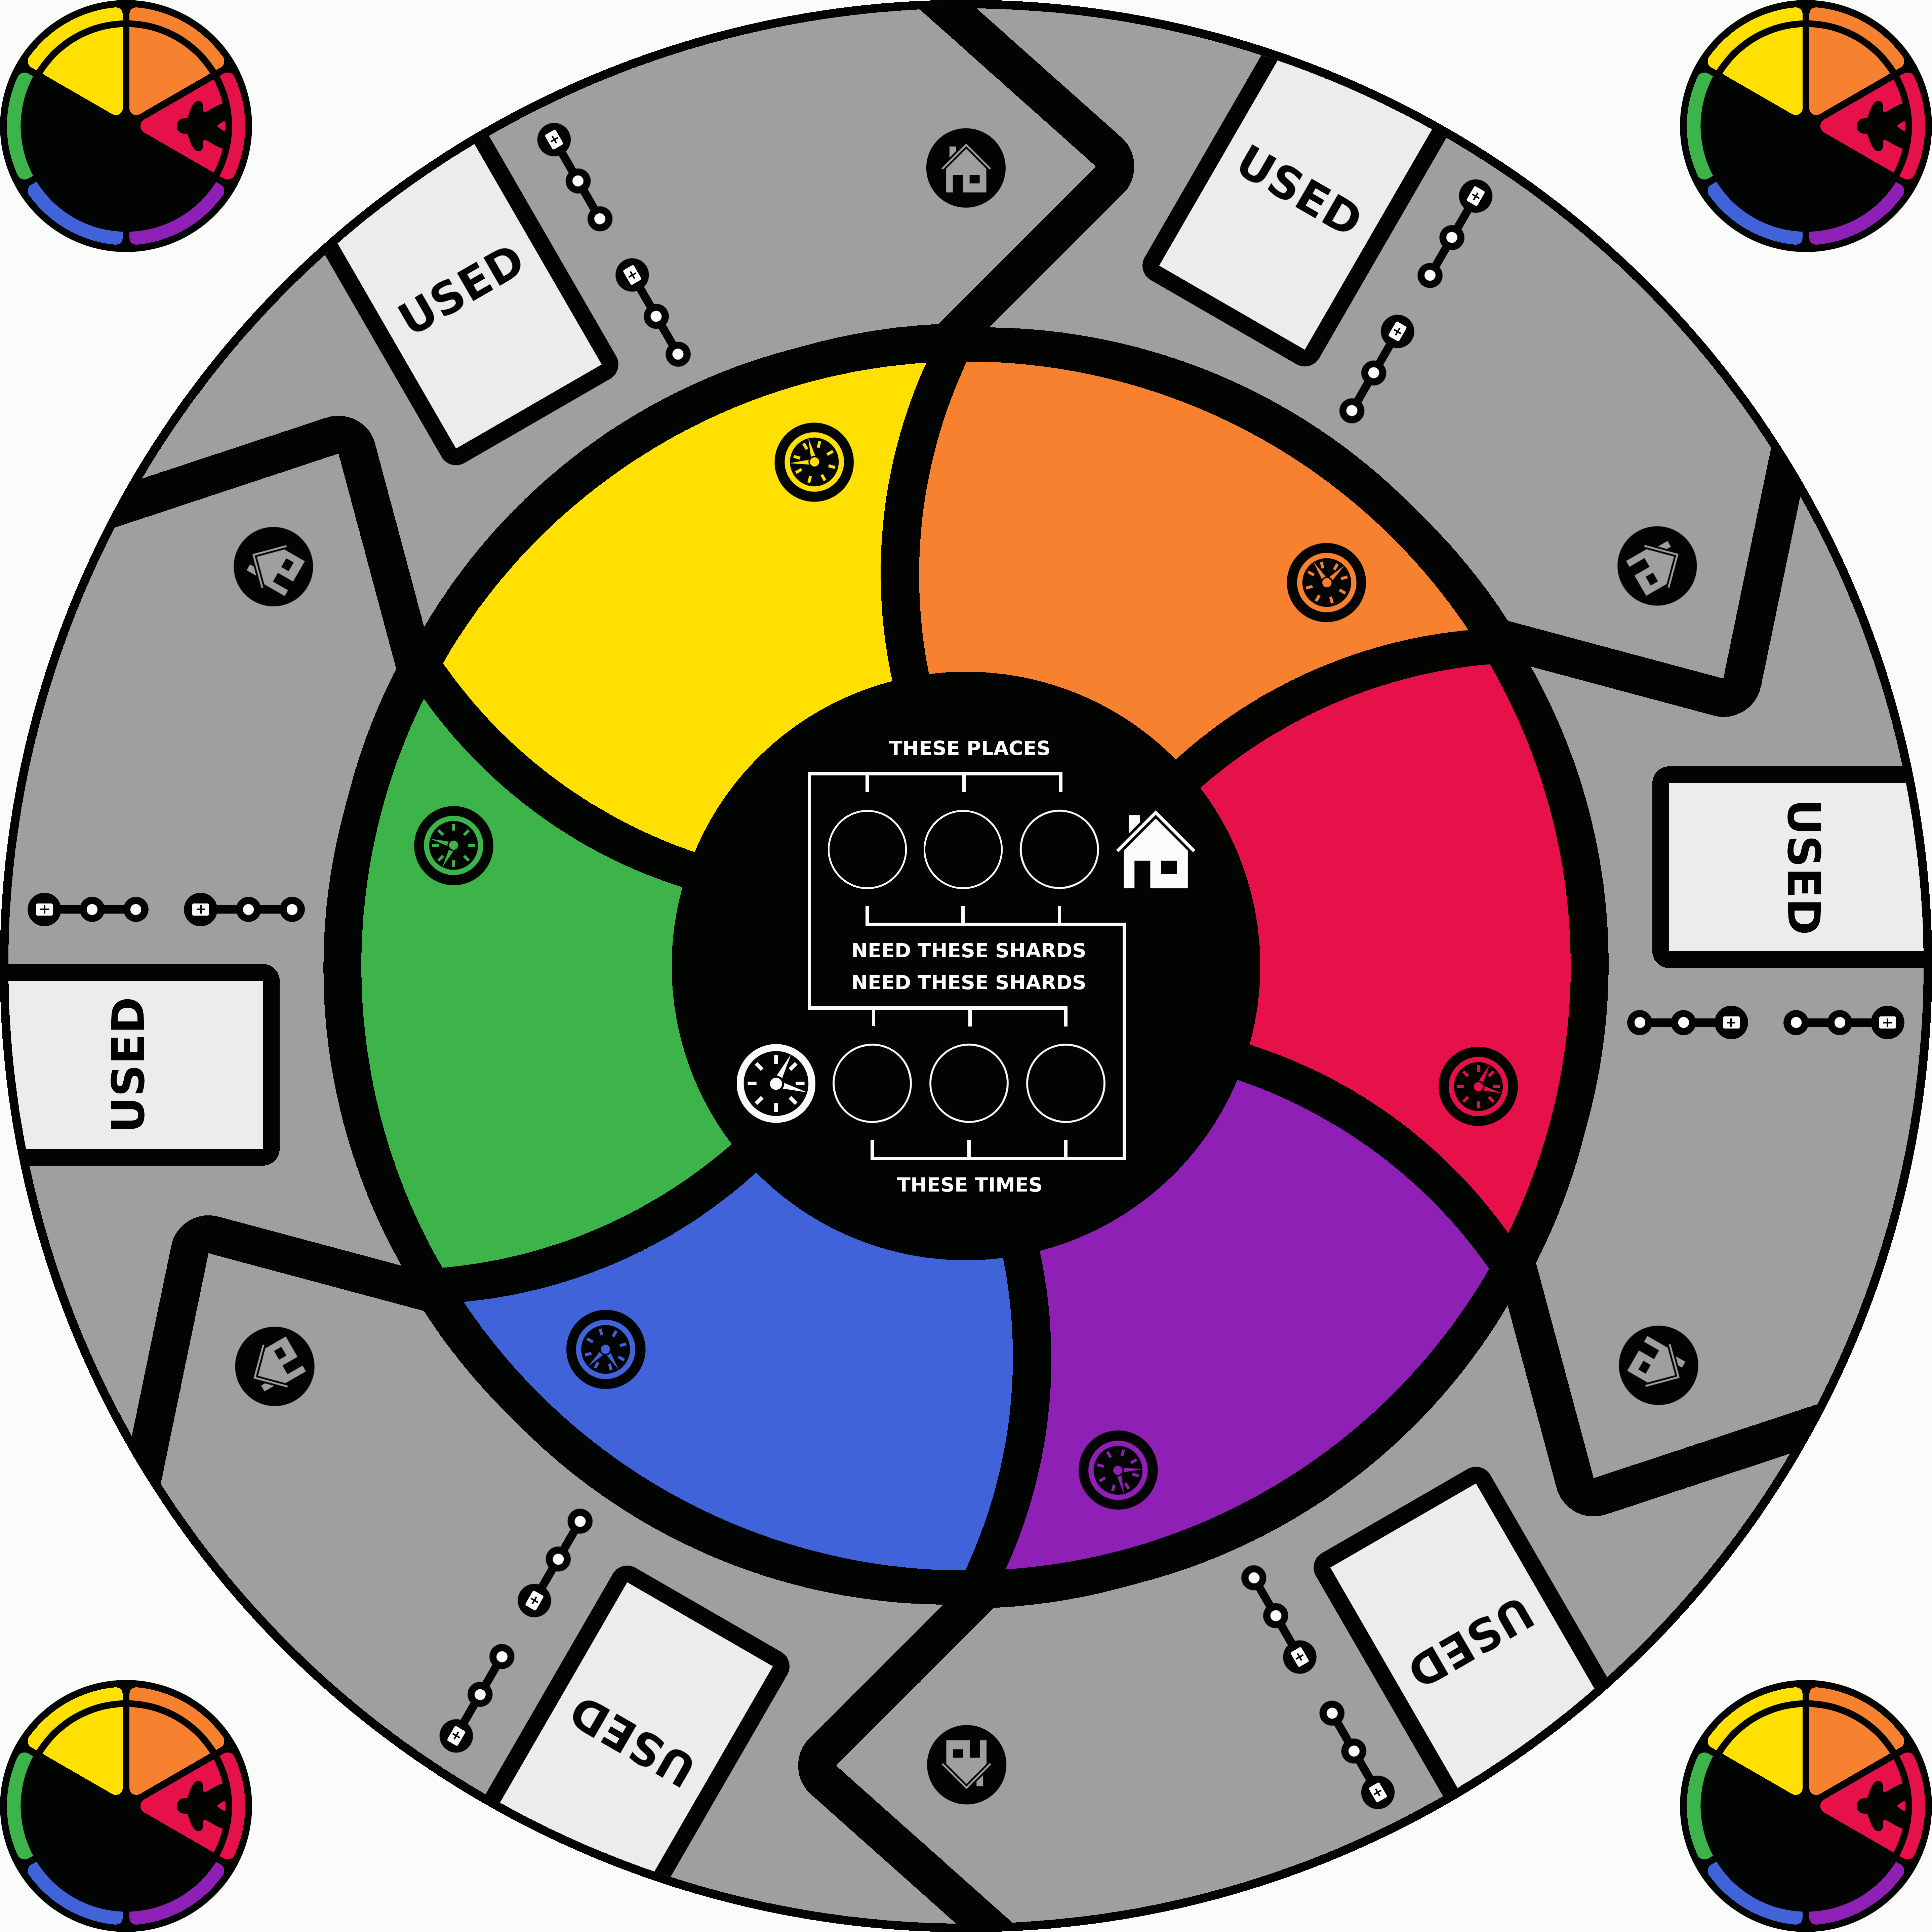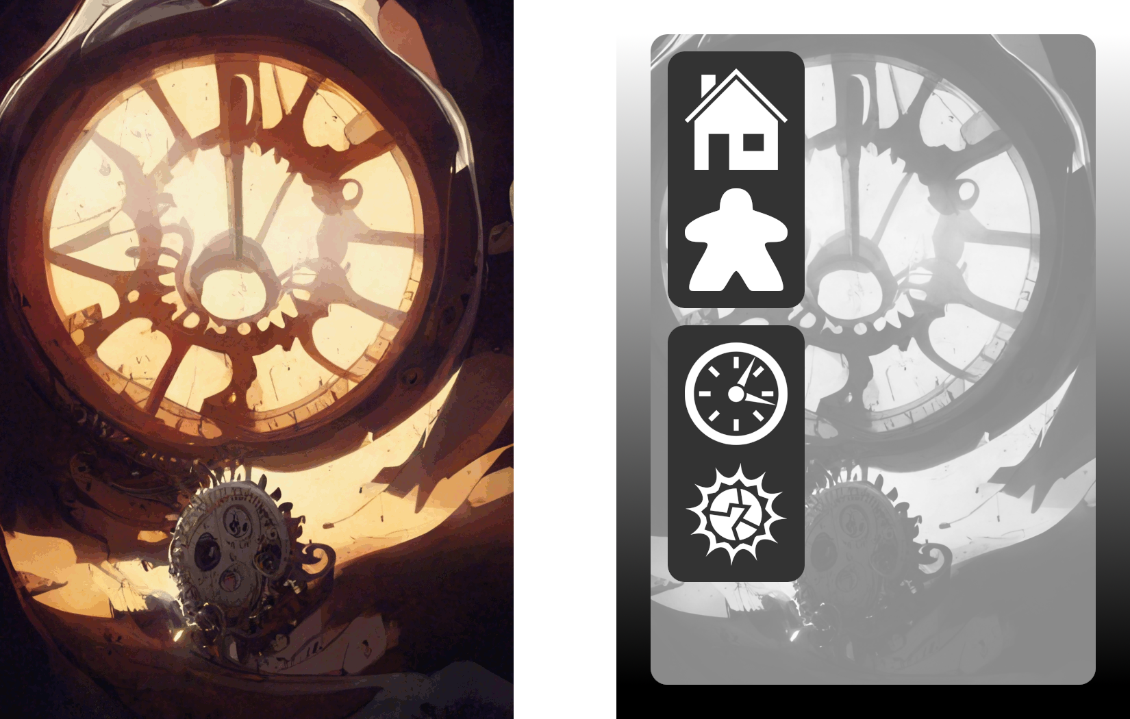

36x Mini Time Marker Tokens – 6 each 12x Player Meeples – 2 each
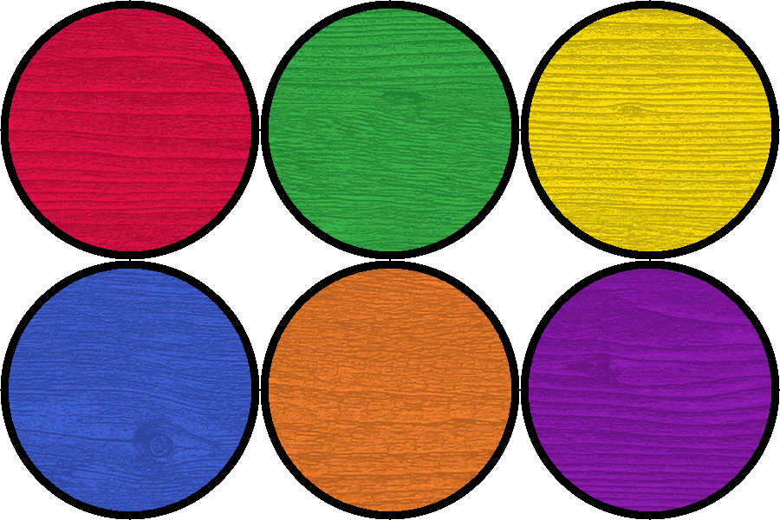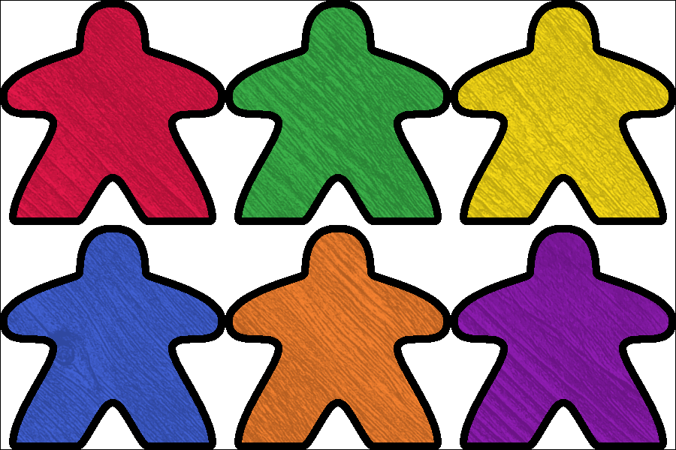
48x Space-Time Shard Tokens – 8 each and double-sided
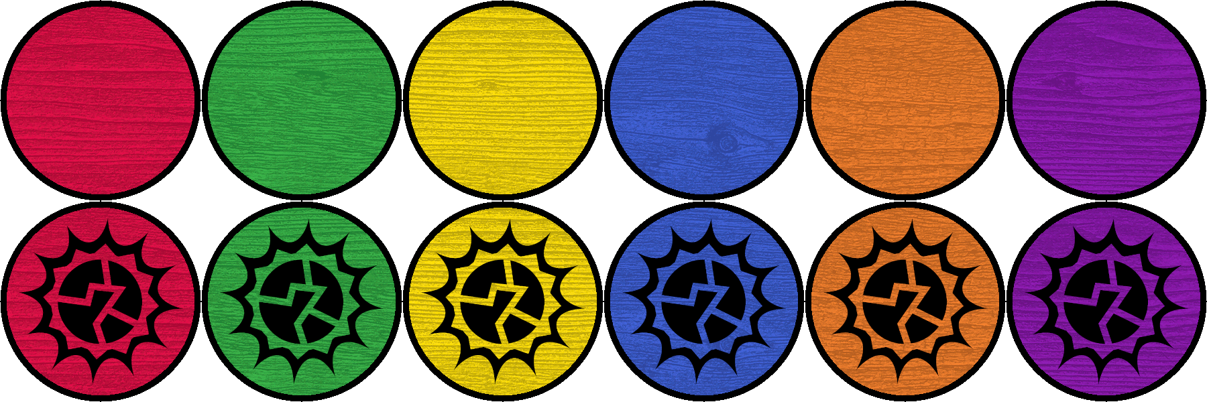
Overview
Throughout the game each player controls 2 meeples: a physical meeple on the places representing where they are and a temporal meeple on the times representing when they are.

The game is played over 2 rounds. For each round there are specific places and times that must be aligned to proceed. Players activate actions on their cards to move about the board and alter space-time shards until the required alignments are complete.

Players must successfully complete both rounds in order to win.
The players lose if all of their cards are spent without completing the round.

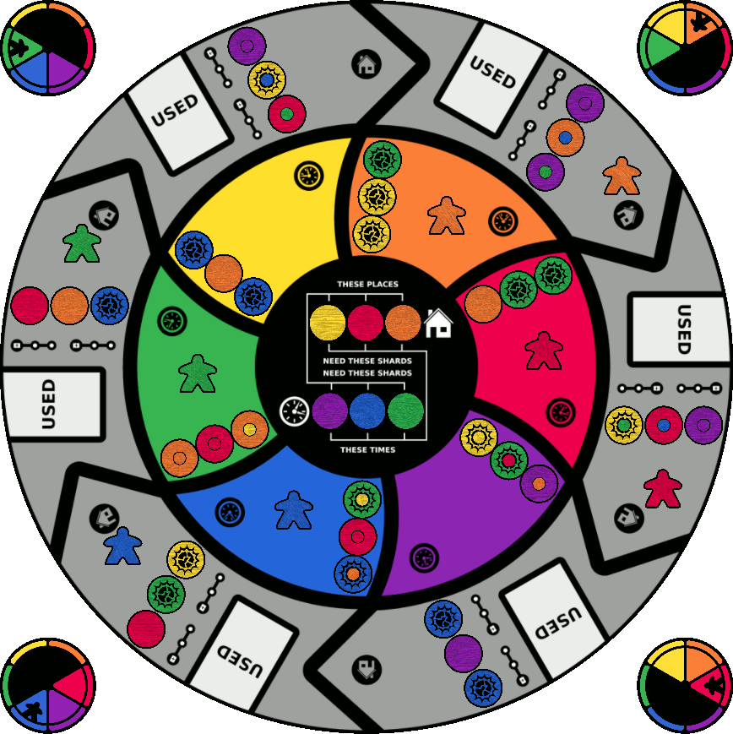
Game Play
Time has looped back on itself, meaning that a player's distant future is also their past. The time that a player’s temporal meeple sits on is their present. The 2 times counter-clockwise from that space are in their past and the remaining 3 times are in their future.

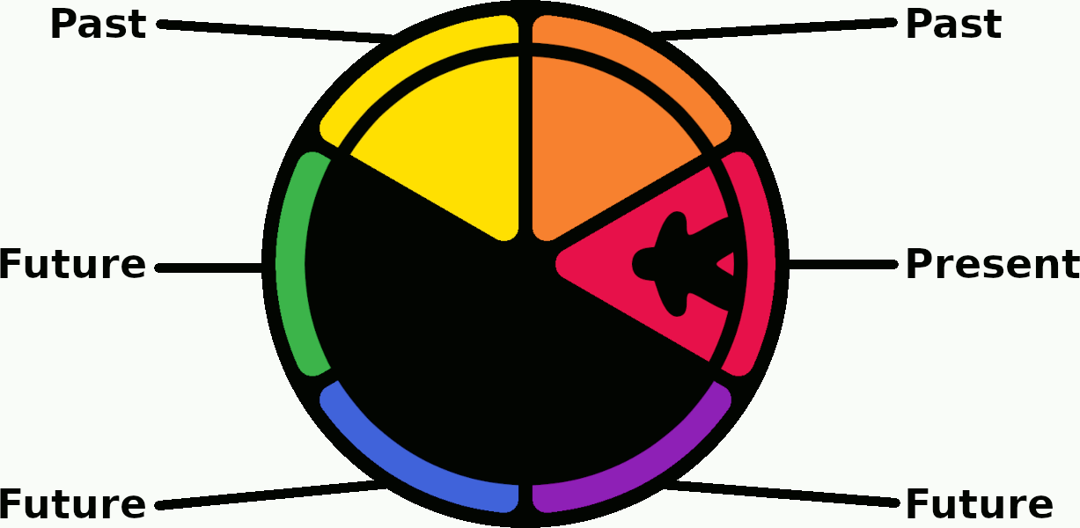

Most actions require a shard to exist for the player in order to be affected. A shard exists for a player if its color matches one of the player’s past or present times. In this example the green, yellow and orange shards exist for the orange player.

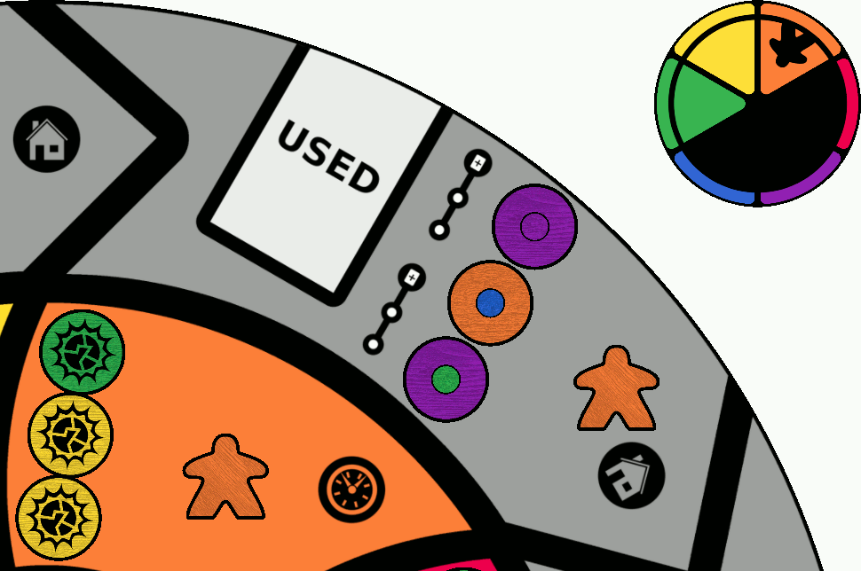

Game Play – Continued
At the start of each round 6 goal tokens will be revealed that represent part of spacetime that has become unstable. Of these 3 represent places and the other 3 represent times.

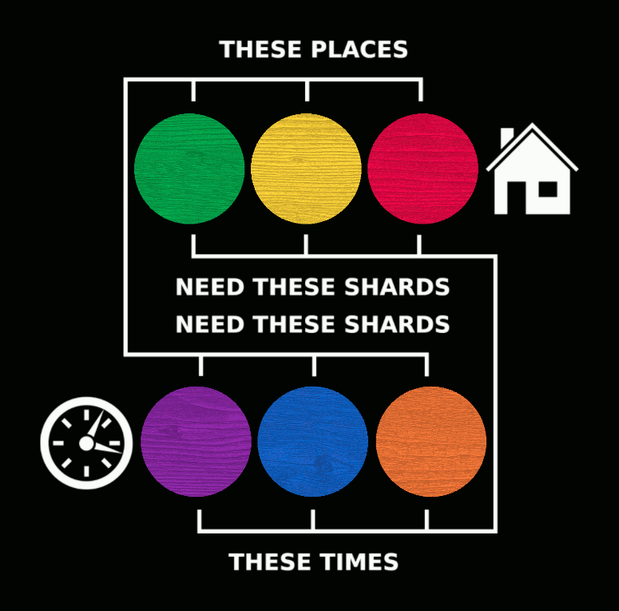

In order to complete the round, players must change the shards on the places matching the goal tokens to contain the shard colors listed on the time goal and change the shards on the times matching the goal tokens to contain the shard colors listed on the place goal.

During setup mini time markers will be placed on the relevant shards to help track this.

Example
The goal area contains green, yellow and red tokens in the place slots as well as purple, blue and orange tokens in the time slots. To complete the round the game board must contain a purple, blue and orange shard each on the green, yellow and red places as well as a green, yellow and red shard each on the purple, blue and orange times – see page 5 for illustration.

Game Play – Continued
Example board with the above goal completely solved (other game elements not shown):

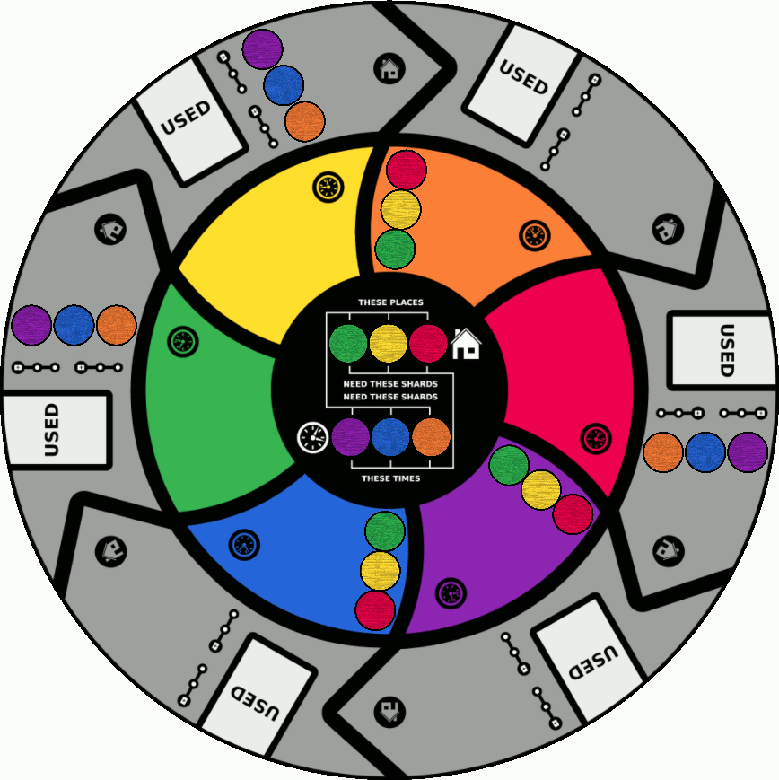

In addition to specific places and times containing specific colored shards the shards themselves must not be distorted. During setup 3 colors will be selected at random with each of the matching colored shards being flipped to their distorted side. Distorted shards do not count toward completing the current round. They can however be repaired to their blank side through player actions.


Actions
Each card has 2 actions available; when played one of the actions is chosen and resolved and then the card is discarded. There are 3 actions each for places and times:

Move
 Move your physical meeple to an adjacent place
 Move your temporal meeple to an adjacent time

Flip
 Flip a shard on your physical meeple’s place to blank-side up
 Flip a shard on your temporal meeple’s time to blank-side up

The shard must exist, i.e., match color with one of the player’s past or present times.

Swap

Swap a shard from the player’s physical meeple’s place with a shard from their temporal meeple’s time

Swap a shard from the player’s temporal meeple’s place with a shard from their physical meeple’s place

The originating shard (underlined) must exist, i.e., match color with one of the player’s past or present times, in order to be swapped. The destination shard may be any color.

Mulligan
In addition to the above players may, at any time, discard 1 card from their hand to the physical meeple’s place in order to place their other 4 cards on the bottom of their deck.

After resolving the chosen action the card is discarded directly to the game board on one of the USED slots. For place effects discard the card to the slot on the player’s physical meeple’s place; for time effects discard the card to the slot on the player’s temporal meeple’s time. The player then draws cards from their deck to refill their hand to 5 cards.
Actions – Continued
Example
Here only the red shard is valid though it can be swapped with any of the time shards.
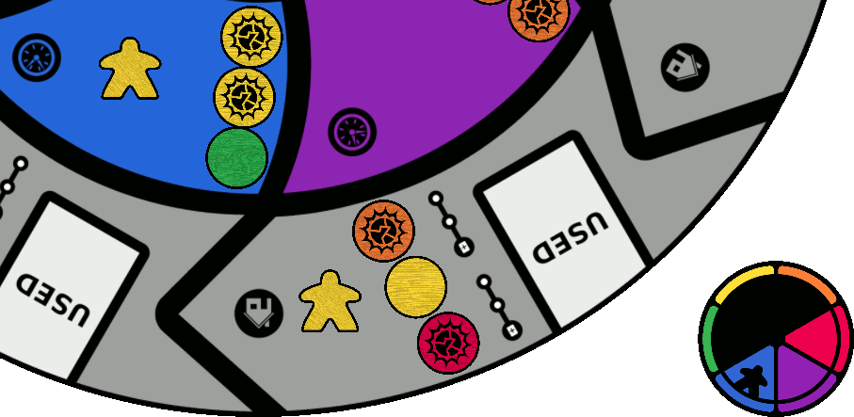

Example
Either of the green shards are valid and could be swapped with any of the place shards.
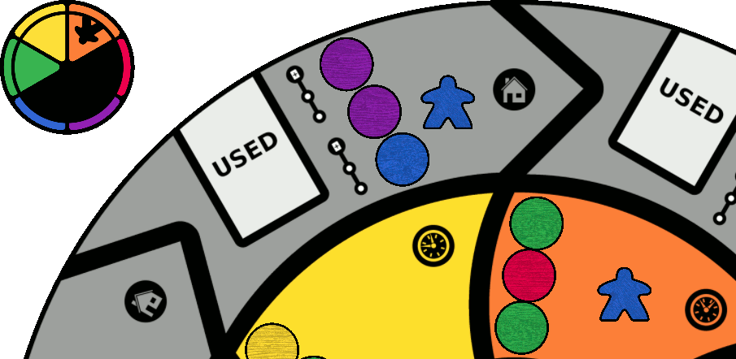
Stability and Rewind
During setup, after revealing the goal for the round, small time maker tokens are placed on each of the spaces which need aligned:

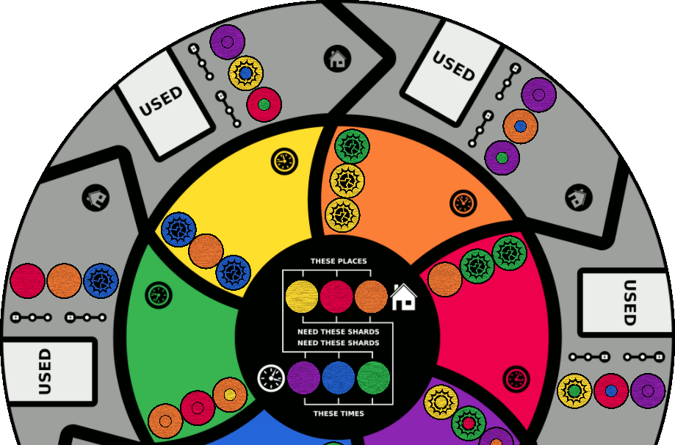

Each time a shard is flipped or swapped so that it is aligned with a matching time marker:
- The player to complete the alignment takes the shard to spend later
- The time marker is moved to the bottom-most available stability slot in its zone
These steps MUST be completed immediately; they cannot be delayed to rewind first.

Example: in the above image the orange and red shards in the green time as well as 3 of the purple shards around the board each match their time markers resulting in the below:

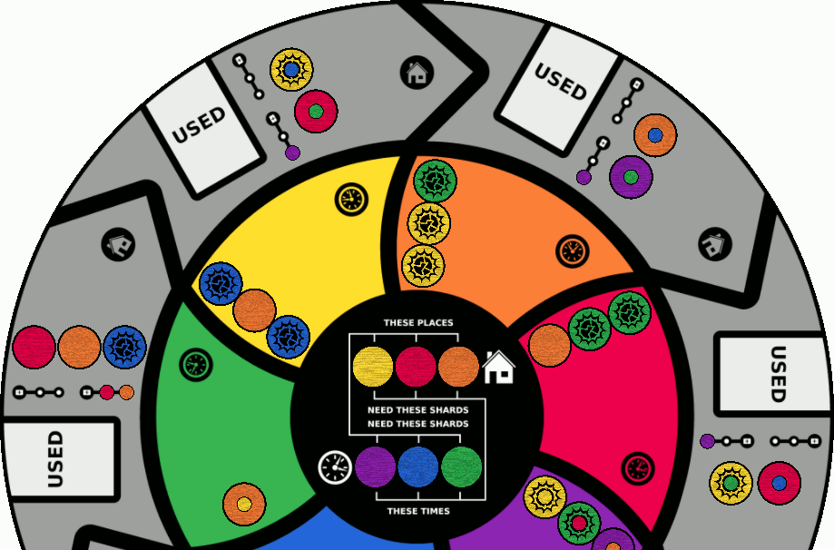
Stability and Rewind – Continued
Cards that have been discarded can be picked back up again by rewinding time by any player. Players can discard one of their shards to the box in order to move the top 2 discarded cards from their physical meeple’s place to the top of their deck.

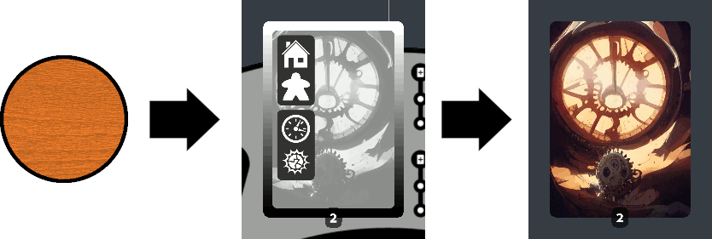

However, as time markers are moved to the places the time on that place begins to stabilize making it more difficult to rewind. Once a place has 3 time markers, covering a draw icon, players can only rewind 1 card from that place. Similarly once a place has all 6 time markers, covering both draw icons, players can no longer rewind time at that place.

Rewind 2 cards Rewind 1 card Cannot rewind

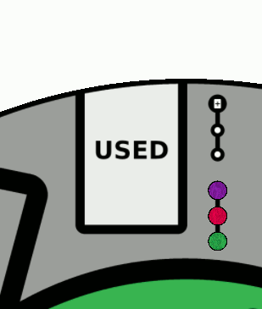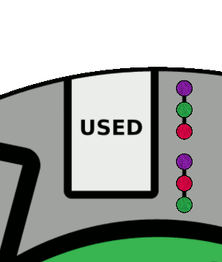

Setup
Place the game board in the center of the table within easy reach of all players.

Separate 1 of each color space-time shard for use as goal tokens. Mix the goal tokens and place them on the 6 goal spaces: 3 for places and 3 for times.

Separate 1 of each color shard for use as damage tokens and set aside.

Mix the remaining shards and randomly place 3 on each place and time blank-side up.

Mix the damage tokens, draw 3 and then flip every shard on the board to their distorted side which match any of the damage token colors. Return the 3 damage tokens to the box and set the remaining 3 aside; they will be used during the 2nd round of the game.

Place time markers on top of the shards which need to be aligned to complete the round’s goal – see pages 4 and 8 for examples.

Each player chooses a color, taking the 2 matching meeples, and then places 1 of the meeples each on their matching colored place and time. Players rotate their time dials to so that their current time color is marked as their present time. Return unused meeples to the box.

Separate the player cards into 4 decks containing 1 of each of the 9 unique cards, shuffle and then divide them among the players:
4 players » Each player takes 1 deck
3 players » Evenly divide 1 deck among the players then each player stacks 1 deck on top
2 players » Each player stacks 2 decks together
1 player » The player stacks all 4 decks together

Note that in a 3-player game the 4th deck should be divided such that each set of 3 cards should have 1 of each action available among its 6 actions.

Players place their decks face-down in front of them and draw a hand of 5 cards.

Setup – Continued
In this example 4 players have completed setup with blue, green and yellow shards being distorted. Each player has a deck of 9 cards; the game is ready to begin.

End Game & Extended Play
The players are free to take actions until either the goal has been completed or the players have ran out of cards. Players do not take turns; they each activate and resolve their actions as quickly or slowly as they wish independently of one another.

Once the 1st goal has been completed perform the following setup for the 2nd goal:
- Swap the 3 place goal tokens with the 3 time goal tokens
- Flip all remaining shards to their distorted side that match any of the remaining damage tokens and then return the damage tokens to the box
- Place time markers on each of the shards according to the new goal

Players continue taking actions until either the 2nd goal has been completed or the players run out of cards.

If the players run out of cards before completing the goal then the players lose the game forever lost as Presentville’s space-time ceases to exist.

Successfully completing the 2nd goal ends the game in victory for the players saving Presentville as place and time restore to their rightful ways.

In this example the goal tokens have been swapped and remaining 3 damage tokens revealed; once the matching shards have been flipped the players can resume play:

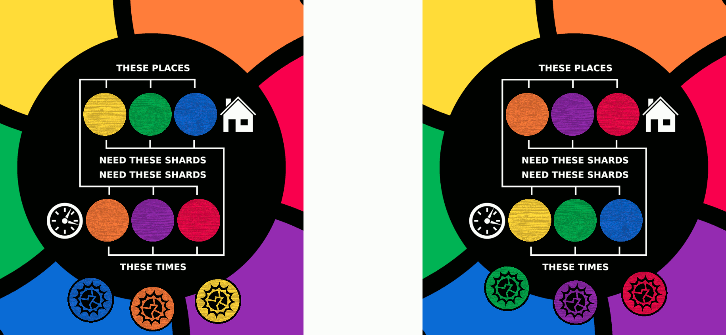

Example Game Play
Here a player has setup for a solo game using the red meeples.

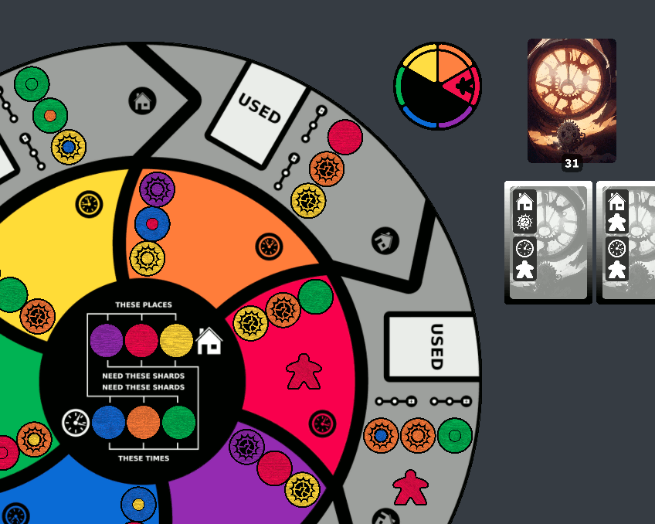

After placing time markers for the 1st goal there are 5 shards already solved so the player collects those shards and moves their time makers to begin stabilizing their zones.

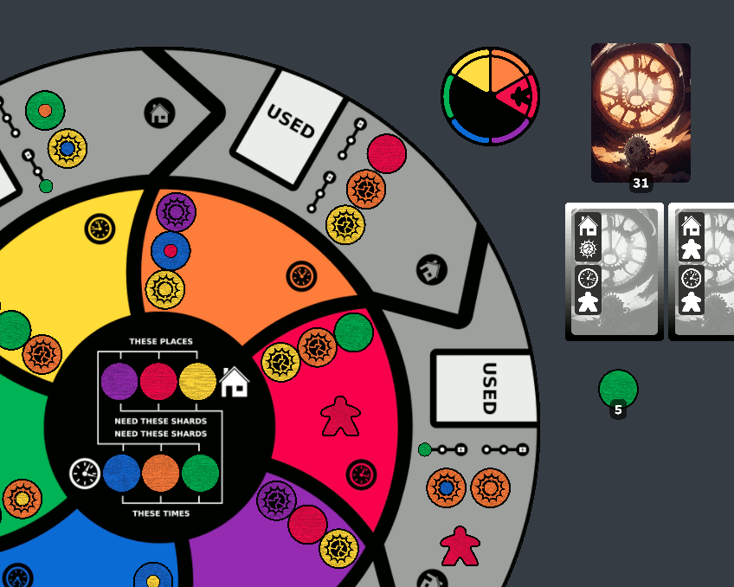

After a look around the board the player notices a quick solution for the red place. They start by resolving a “place flip” action to align one of the orange shards on their place and then discard the card to the USED slot on the red place.

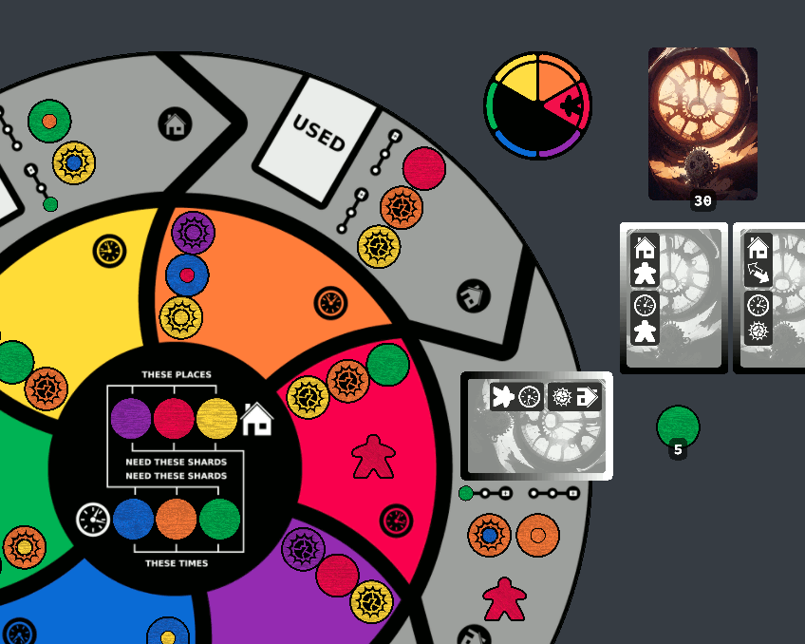

They then collect the aligned orange shard and moved the time marker to further stabilize the red place. Next they resolve a “time move” action to move their temporal meeple to the orange time then discard the card to the USED slot of the orange place.

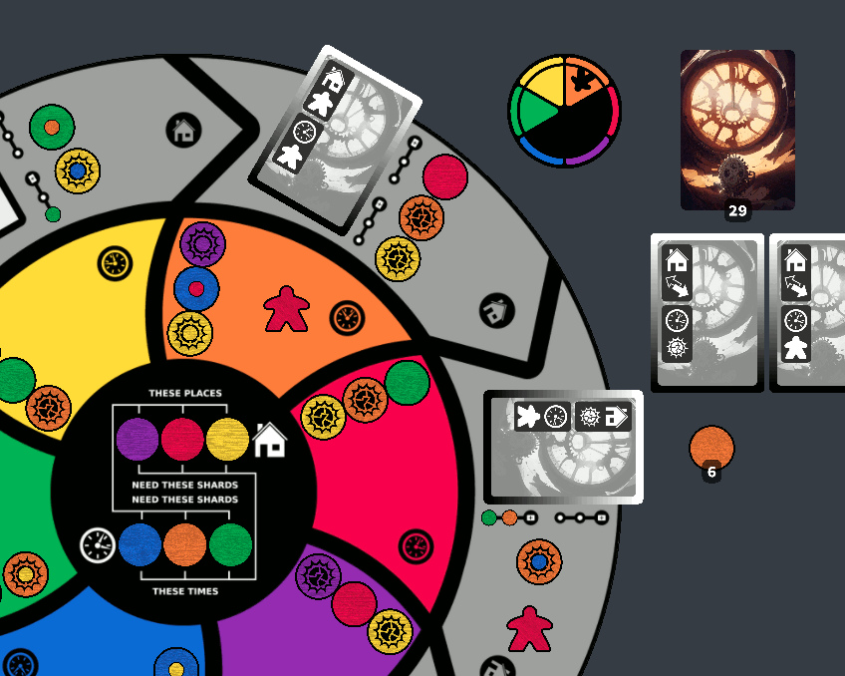
Example Game Play – Continued
Lastly they activate a “place swap” action to swap the orange shard on the red place with the blue shard on the orange time. The card is discarded to the USED slot on the red place. While the player would like to rewind to take the 2 cards on the red place for a single shard they must first finish resolving the newly aligned blue shard by collecting it and moving its time marker.

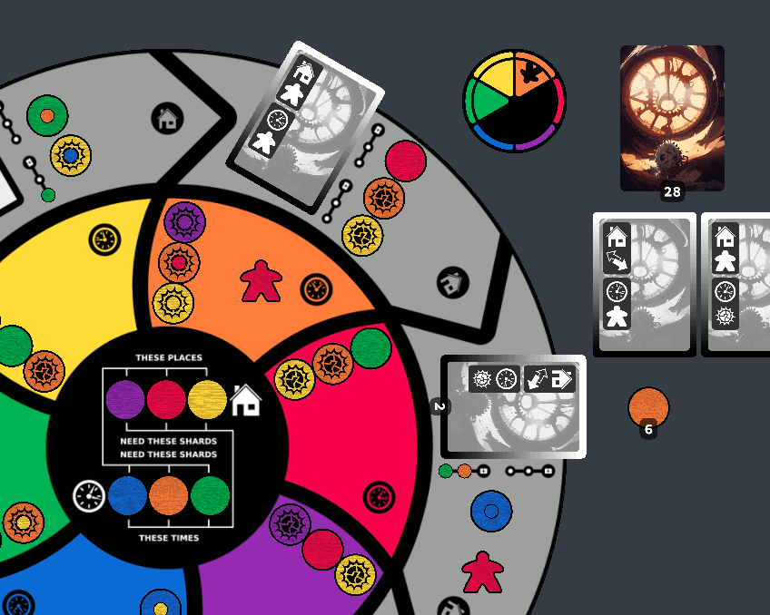

With the 1st draw icon covered rewinding on the red place will now only provide 1 card.

